Codes of Conduct
Codes of Conduct for adults working with children and young people, parents/carers, and children and young people

A Code of Conduct has several important functions:
- It sets out what behaviour is acceptable and unacceptable and provides transparency for all on what practice and behaviours to expect from others
- It defines standards of practice expected from those to who it applies
- It forms the basis for challenging and improving poor practice and behaviour.

The sports volunteers/staff, parents/carers, and children and young people support and understand codes of conduct best when they are involved in drawing them up and have an opportunity to discuss what is acceptable and unacceptable behaviour.

Adults working or volunteering with children and young people

Everyone working with children and young people on behalf of your sports organisation should sign up to a Code of Conduct that outlines expected standards of practice and behaviour. Members of the sports volunteers/staff must be clear about the expectations on them when involved in activities with children. Children and young people and the parents/carers involved in activities should also be clear about what they can expect from the adults working with them. The Code of Conduct for working with children and young people is most useful if shared publicly and widely.

Volunteers/staff should be given the opportunity to discuss their conduct in order to ensure that they have understood what it means for them in their role.

As children and young people have the right to know what is expected of the adults in the organisation it is important that there is an accessible version for them.

Children and young people

It can be very beneficial to ask children and young people as a group to discuss what behaviours and practices are acceptable and unacceptable while participating in a team, on a programme or at a club. This conversation should also include agreement about what the consequences of not following their Code of Conduct should be. This could be done at the start of a season, before a trip away from home, or as part of a welcome session at a residential camp. The Code of Conduct should include how young people should treat each other with respect and be aware of the potential damage of peer on peer bullying.

Parents/Carers

The conduct of parents/carers is important in promoting a positive experience for both their own child and for other children and young people participating in sport. This is about positive and supportive encouragement in general. Good spectator behaviour is one element of this. Poor behaviour by adults on the side-lines can distract some children and young people and in the worst case may risk a child or young person dropping out of sport. Sports organisations should have a Code of Conduct for parents/carers which promotes positive behaviour and clarifies the consequences of breaching it.

Templates

The following templates are guides only. These provide a starting point for your organisation to develop Codes of Conduct that fit your sports organisation and the coaches, volunteers, children and young people and parents/carers involved in it. Remember involving your target audience in the development of your Codes of Conduct can encourage greater buy-in. It is recommended that you have a mechanism of evidencing that the individual has read the Code of Conduct. This can make breaches of the Code of Conduct more easily managed and protect against the defence that they had not seen it or read it.

TEMPLATE: Code of Conduct for adults working/volunteering with children and young people
A Code of Conduct has several important functions:
- It sets out what behaviour is acceptable and unacceptable and provides transparency for all on what practice and behaviours to expect from others
- It defines standards of practice expected from those to who it applies
- It forms the basis for challenging and improving poor practice and behaviour.

[Organisation name] supports and requires all members to observe the following standards of practice, including verbal and non-verbal actions when working/volunteering with children and young people.

All concerns about breach of this Code of Conduct will be taken seriously and responded to in line with [Organisation name] appropriate policy/procedure. This may include the Responding to Concerns Procedure, Complaints Procedure, and/or Disciplinary Procedure.

Good practice

- Make sport fun, enjoyable and promote fair play.
- Treat all children and young people equally, with respect, dignity and fairness. Challenge where you see other adults or children and young people participating in disrespectful or bullying behaviour.
- Involve parents/carers wherever possible.
- Build balanced relationships based on mutual trust.
- Include children and young people in decision-making processes.
- Always work in an open environment, wherever possible. Avoid private or unobserved situations.
- Put the wellbeing of each child or young person first before winning or achieving performance goals.
- Be an excellent role model including not smoking, drinking alcohol, taking drugs or swearing in the company of children and young people.
- Recognise the developmental needs and capacity of children and young people.
- Avoid excessive training and competition, pushing children and young people against their will and putting undue pressure on them.
- Follow [Organisation name] Digital Communication and Social Media guidance in relation to communicating with children and young people.

Practice to be avoided
In the context of your role within [Organisation name], the following should be avoided:
- Having ‘favourites’ – this could lead to misinterpretation, or resentment and jealousy by other children and young people.
- Spending excessive amounts of time alone with children and young people away from others.
- Entering children or young people’s bedrooms on trips away from home, unless in an emergency or in the interest of health and safety.
- Where possible, doing things of a personal nature for children or young people that they can do for themselves.
- Contacting children and young people online outside [Organisation Name] Digital Communication and Social Media guidance.

Unacceptable practice

In the context of your role within [Organisation name], the following practices are unacceptable:
- Allowing allegations made by a child or young person, or about the wellbeing or protection of a child or young person, to go unrecorded and unreported.
- Forming intimate emotional, physical or sexual relationships with children or young people.
- Making sexually suggestive comments to a child or young person, allowing or engaging in touching a child or young person in a sexually suggestive manner, or engaging in sexually provocative games.
- Being physically violent towards a child or young person.
- Allowing children or young people to swear or use sexualised language unchallenged.
- Behaving in a coercive or controlling manner towards a child or young person.
- Allowing a child or young person to share a room alone with a coach or adult member or inviting a child or young person into your home.

TEMPLATE: Code of Conduct for parents and carers
- Remember that children and young people play for enjoyment as well as competition.
- Remember that your behaviour may affect not only your child but the other children and young people participating.
- Stay outside the field of play and in the Spectator’s Area (where provided).
- Never engage in, or tolerate, offensive, insulting or abusive language or behaviour.
- Always respect the match officials' decisions.
- Applaud effort and good play as well as success.
- Let the coaches do their job and not confuse the players or athletes by telling them what to do.
- Encourage the players and athletes to respect the opposition and match officials.
- Never criticise a player or athlete for making a mistake. Remember that mistakes are an important part of learning and wellbeing
- Pass on any concerns that you have about the wellbeing of a child or young person to a club official.
I understand that breaches of the code may result in action being taken by [Organisation Name].
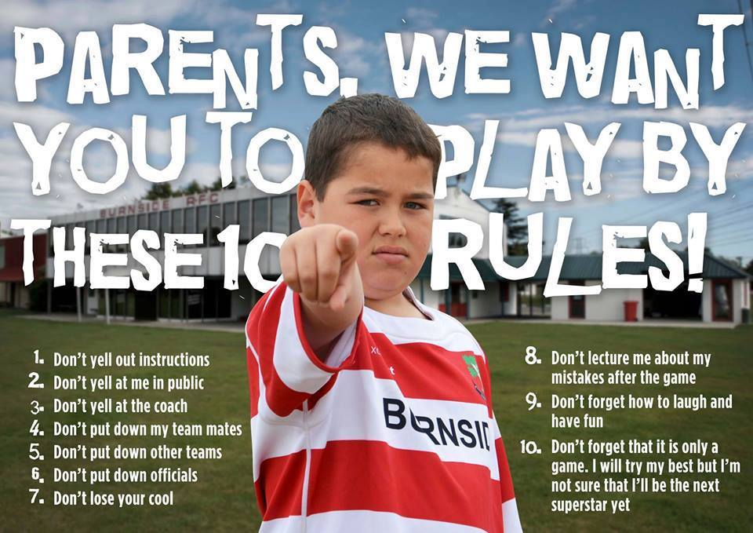
If you have any concerns about the wellbeing of a child or young person, you can contact: [Organisation’s Lead Child Wellbeing and Protection Officer], Child Wellbeing and Protection in Sport on 0141 419 1156 or Children 1st Parentline on 08000 28 22 33.

TEMPLATE: Code of Conduct for children and young people

Adults at [Organisation Name] should help to make sport safe and fun. This is your job too. This means respecting other players/athletes and the people who are there to help you to learn. You should do this by:

- Being ready and on time for training and competition
- Respecting the coach and other helpers
- Accepting what the coach or match officials ask you to do in the rules of the game
- Playing to the best of your ability
- Never swearing at or insulting anyone, including other players
- Telling your parents or carers where you are, or if you are going to be late
- Following advice from sport doctors or physios to keep you safe and injury free
- Never bullying other players/athletes either yourself or in a group.

Bullying can happen between children or between adults and children. It means things like:

- name calling
- making fun at someone’s expense
- giving only negative feedback
- hitting
- shoving
- stealing
- damaging belongings
- spreading rumours
- making threats
- sending/posting nasty messages
- leaving people out on purpose.

If you are worried about something don’t keep it to yourself. Speak to an adult who you know and trust such as a parent, coach, teacher, the Child Wellbeing and Protection Officer at your club, a guidance teacher, doctor or school nurse.

If there isn’t anyone you can talk to, you can contact Childline in Scotland on 0800 1111 or at childline.org.uk. It’s free, private and confidential.

