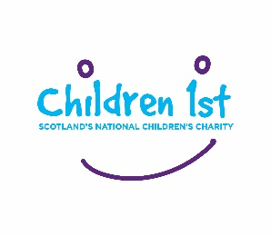
Dragon’s Glen Junior – Business Plan Form
One you have decided to take part in Dragon’s Glen Junior, please fill out this form and return to us via email: fundraising@children1st.org.uk or by post to: Children 1st, Supporter Care Team, 83 Whitehouse Loan, Edinburgh, EH9 1AT.
Your plan will be reviewed by our Fundraising Products and Innovation Lead, who will decide in investing the £100 seed funding in your proposal.
Should we have any questions, we will get in touch with your responsible adult to discuss further.
Your Team: Enter your Company / Team name, and the names and ages of the members involved below

Company / Team Name
Name |  | Age
Your Business Case
Please tell us about your proposal and what you plan to do.

Responsible Adult Details
The below details must be filled out by an adult over the age of 18 years old. This person will be responsible for receiving the seed money of £100 and making the donation to Children 1st once the challenge is completed.
Title
First Name
Surname
Address Line 1
Address Line 2
Town
Country
Postcode
Telephone
Email Address
Declaration | I understand that by completing this form I am responsible for the receipt of the Dragon’s Glen Junior seed funding, and for any money raised.
Signed
Please enter the account details of the responsible adult who will receive the seed money, subject to approval of the business plan. We may need to contact you to confirm these details prior to transfer.
Bank Name
Name on Account
Account Number
Sort Code

Keeping in Touch
You are a vital part of the Children 1st family. Your passion, generosity and determination help to change children’s lives for the better is greatly appreciated. So that we can share further updates about the work of Children 1st, or request your feedback in the future, please indicate how you would like to remain in contact:
I am happy for you to contact me by:
Email □
SMS □
Phone □
We will contact you by post unless you tell us otherwise. We will send you news, campaigns, and fundraising appeals.
□ No thank you, I would rather not receive post from you
For more information on how we collect, use, and store your personal information in line with data protection laws, please see our Privacy Policy at children1st.org.uk/terms-and-conditions/privacy-policy.

